KAWASAKI - BIERE LARUE
VIETNAM INTERNATIONAL SERIES 2014

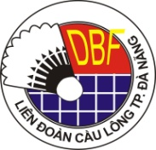

FLIGHT DETAILS FORM

Please complete and return this Form to vietnamseries2014@gmail.com; vbf@fpt.vn or fax at +84 437336046 before/by 15th September 2014.

Name of Member Association:
Contact Person:
PHONE NUMBER: | MOBILE NUMBER:
FAX NUMBER: | E-MAIL:
Please type clearly in CAPITAL LETTERS.

Group 1 | ARRIVAL | DEPARTURE
Day/Date
Time
Flight No.
Total no. of person
Name of Group Leader
Airport | Da Nang International Airport

Group 2 (if any) | ARRIVAL | DEPARTURE
Day/Date
Time
Flight No.
Total no. of person
Name of Group Leader
Airport | Da Nang International Airport

